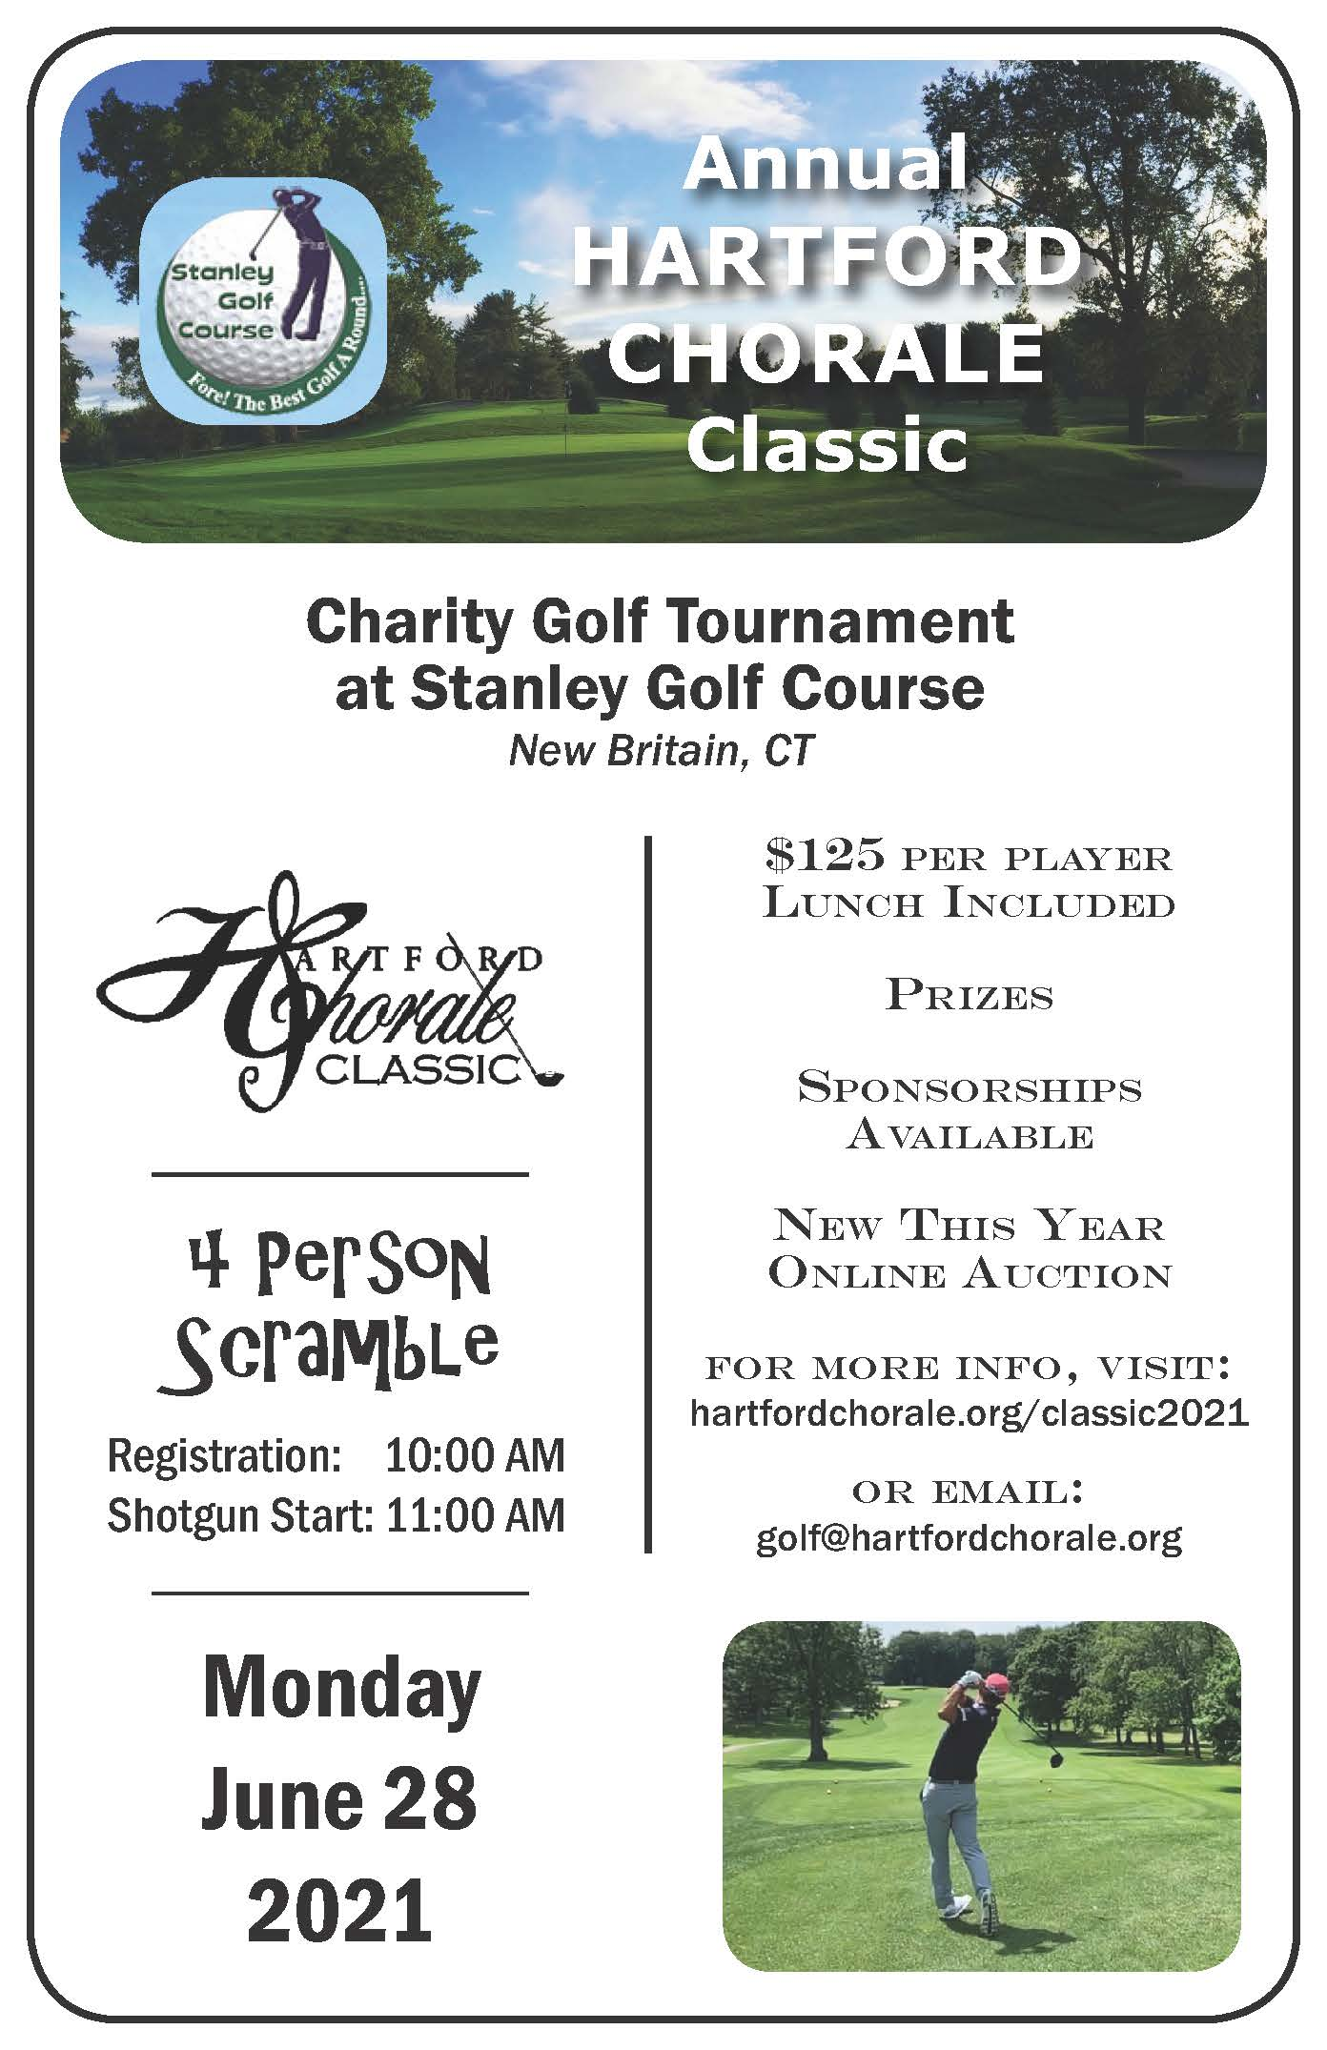
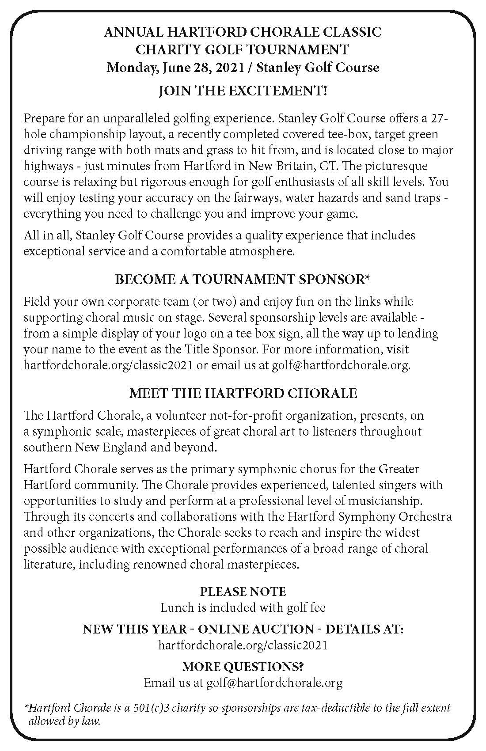

PLAYER REGISTRATION
Registration fee is $125.00 per player
Registrations are accepted in pairs or foursomes
Each golf tournament player registration includes lunch and a shared golf cart
The tournament will be limited to the FIRST 32 TEAMS (or equivalent)
which have PAID AND SUBMITTED their registration.

Player 1:
Mailing Address:
City, St, Zip:
Phone:
*Email:

Player 2:
Mailing Address:
City, St, Zip:
Phone:
*Email:
Player 3:
Mailing Address:
City, St, Zip:
Phone:
*Email:

Player 4:
Mailing Address:
City, St, Zip:
Phone:
*Email:
*NOTE: all tournament communications will be done by e-mail
Registration payment accepted by credit card or check.
Credit card payments:

Player 1: Amex☐ Visa ☐ MC☐ Discover ☐
Name on Card:
Card #
Exp date

PLAYER 1 PAYING FOR ALL OTHER PLAYERS ☐

Player 2: Amex☐ Visa ☐ MC☐ Discover ☐
Name on Card:
Card #
Exp date
Player 3: Amex☐ Visa ☐ MC☐ Discover ☐
Name on Card:
Card #
Exp date

Player 4: Amex☐ Visa ☐ MC☐ Discover ☐
Name on Card:
Card #
Exp date

Registration payments accepted by credit card, check or PayPal payment at Hartford Chorale Website. Checks should be made payable to Hartford Chorale.

Please complete form and return with registration fee by June 14, 2021 to:
Hartford Chorale Classic
233 Pearl Street, Mailbox #17
Hartford CT 06103
or email completed and saved form to golf@hartfordchorale.org
SPONSORSHIPS

TITLE SPONSOR - $3,000 Donation $5,000 Donation
- Tournament registration for 8 players*
- Company logo on banner at tournament
- Sponsorship recognition in golf program
- Name in title position on event scorecards
- Name in title position on sponsor tee box sign at event
- Name in title position on sponsor list on CHORALE website

TOURNAMENT HOST SPONSOR - $2,000 Donation
- Tournament registration for 8 players*
- Company logo on banner at tournament
- Sponsorship recognition in golf program
- Name in prominent position on sponsor tee box sign at event
- Name in prominent position on sponsor list on CHORALE website

DIAMOND IN THE ROUGH SPONSOR - $1,000 Donation
- Tournament registration for 4 players*
- Sponsorship recognition in golf program
- Name on sponsor tee box sign at event
- Name on sponsor list on CHORALE website

HOLE SPONSOR - $750 Donation
- Tournament registration for 4 players*
- Name on sponsor list on CHORALE website
- Name on sponsor tee box sign at event

TEAM SPONSOR - $600 Donation
- Tournament registration for 4 players*
- Name on sponsor list on CHORALE website
- Name on sponsor tee box sign at event

TEE BOX SPONSOR - $100 Donation
- Name on sponsor list on CHORALE website
- Name on sponsor tee box sign at event

*Each golf tournament player registration includes lunch and a shared golf cart.
Yes, I’d like to be a Sponsor of the
Third Annual Hartford Chorale
Classic Charity Golf Tournament!
Check participation level below.
- Title Sponsor $3,000 ☐
- Tournament Host Sponsor $2,000 ☐
- Diamond in the Rough Sponsor $1,000 ☐
- Hole Sponsor $750 ☐
- Team Sponsor $600 ☐
- Tee Box Sponsor $100 ☐
*SPECIAL DRINKS CART SPONSORSHIP $500 ☐

Sponsor Name:
Address:
City: State: Zip Code:
Contact Name:
Phone:
E-mail:

The tournament will be limited to the FIRST 32 TEAMS
which have PAID AND SUBMITTED their registration.

Amex☐ Visa☐ MC☐ Discover ☐
Name on Card:
Card # Exp date
Signature (required) _______________________________________

Checks should be made payable to Hartford Chorale.

Please complete this sponsorship form and return by June 14, 2021 to:
Hartford Chorale Classic
233 Pearl Street, Mailbox #17
Hartford CT 06103
or email completed and saved form to golf@hartfordchorale.org (digital signatures accepted)

